**Lesson 6 Demo 3**

**Setting up Slack Notifications from Jenkins**



Steps to be followed:

1. Login or create account on slack to configure channel for alerts.
2. Log in to Jenkins CI tool and configure Slack notification plugin.
3. Configure Jenkins job for setting up Slack notifications.

**Step 1: Login or create account on slack to configure channel for alerts.**

1. Login to Slack workspace and then click on Add Apps option in left side menu to create a new Jenkins integration.

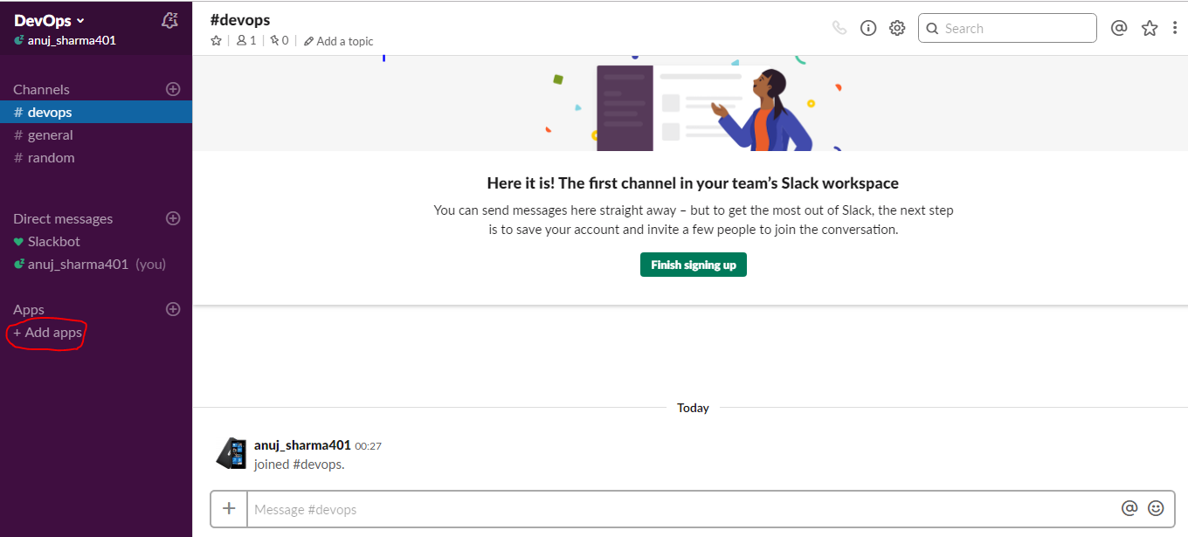

1. Select the Jenkins CI application and then add the channel details to save the integration.

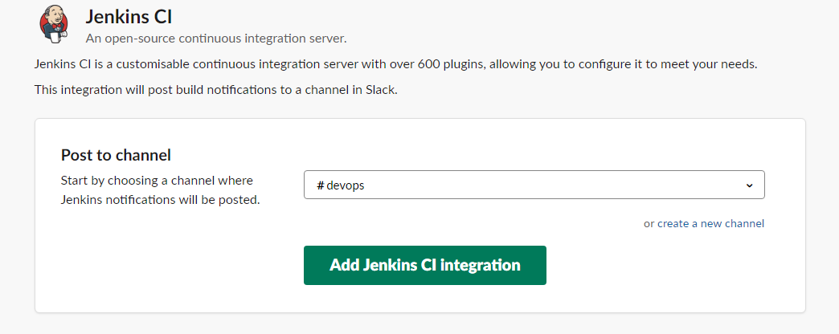

1. Then, get the Setup instructions page which will be having a complete configuration procedure which can be used to have integration between Jenkins and slack.

**Step 2: Log in to Jenkins CI tool and configure Slack notification plugin.**

1. Log in to Slack workspace and then click on Add Apps option in the left side menu to create a new Jenkins integration.
2. Then install the Slack Notification plugin in Jenkins as per the below screenshot.

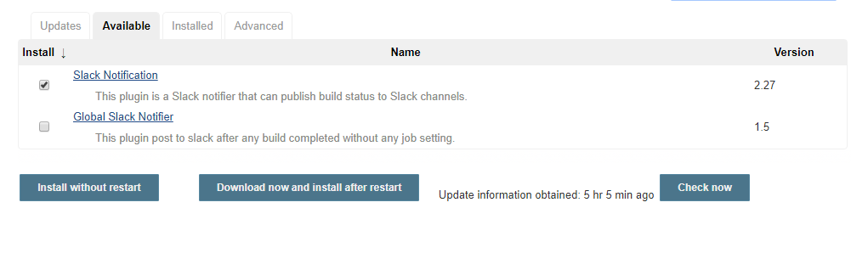

1. Once the plugin is installed, configure the slack channel to send notifications to slack from Jenkins. Use below screenshot settings to perform integration.

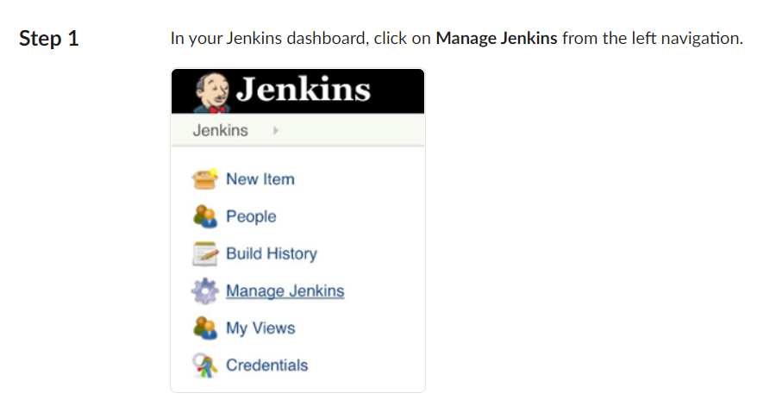

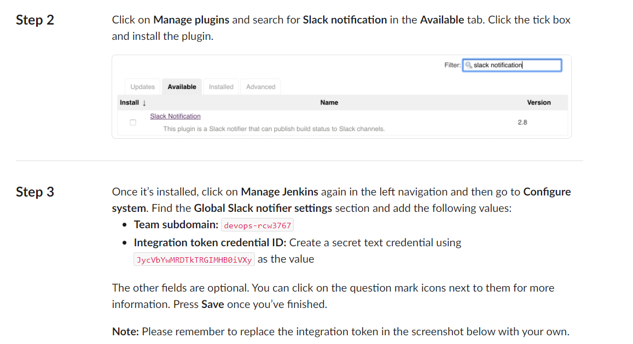

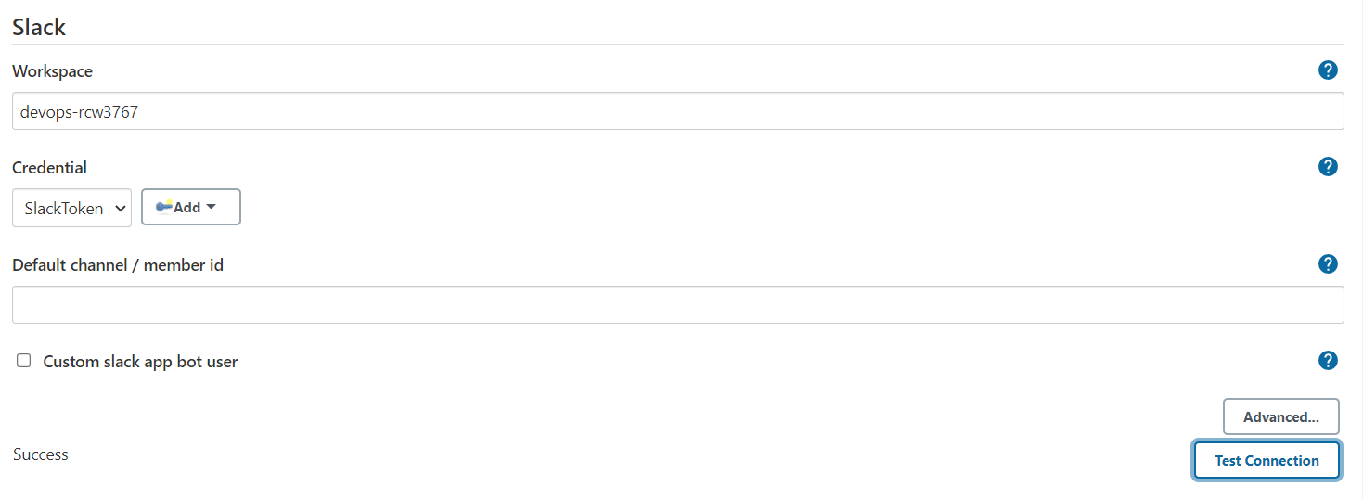

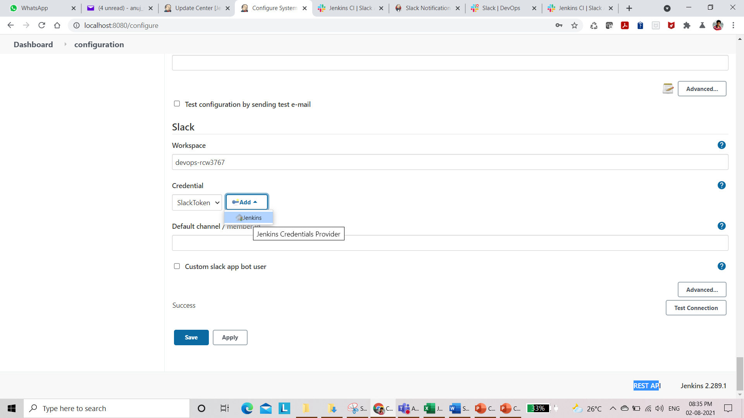

Once you specify Slack Workspace Click on Add button to add a Credentials of Type Secret Text and provide Integration Token.

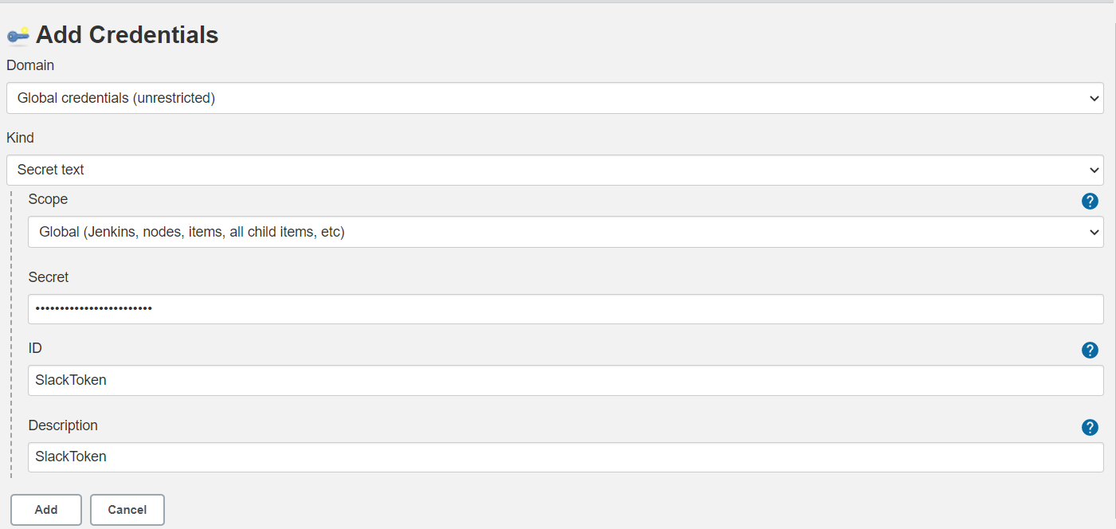

**Step 3: Log in to Jenkins CI tool and configure Slack notification plugin.**

3.1 Now you have to create Jenkins jobs so that user can get notifications with the status of this Jenkins job. Configure Slack Notifications in Post-build Actions so that users can receive alerts in the slack channel.

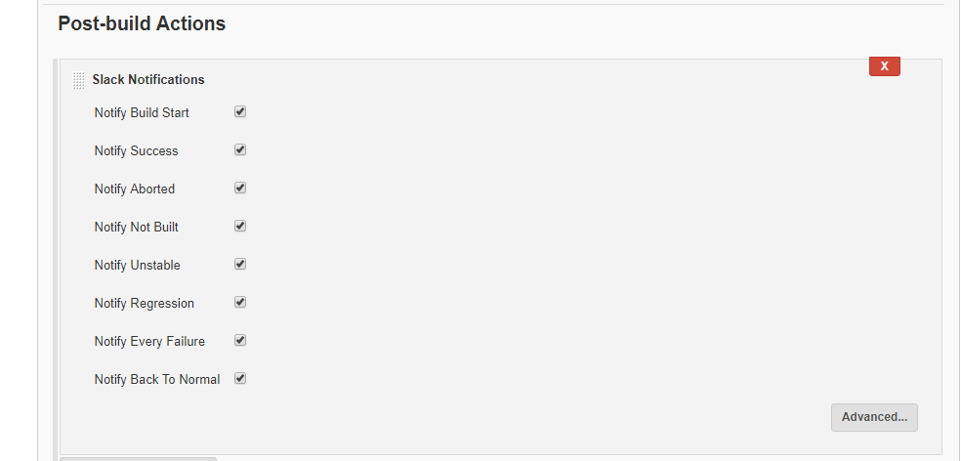

**3.2** Once the build is triggered you will be able to see the Alert message coming in the DevOps channel. This will help us to get instant notifications for our build status.

